# USMAN BASHARAT

000874782

# Flowchart

* 1. Load the Crocodile Clips Software and implement the example flowchart above to find the sum of first 50 integer numbers  
     (If the flowchart will not run correctly, select the space tag, select, flowchart properties select Maximise Range of Variable Values)

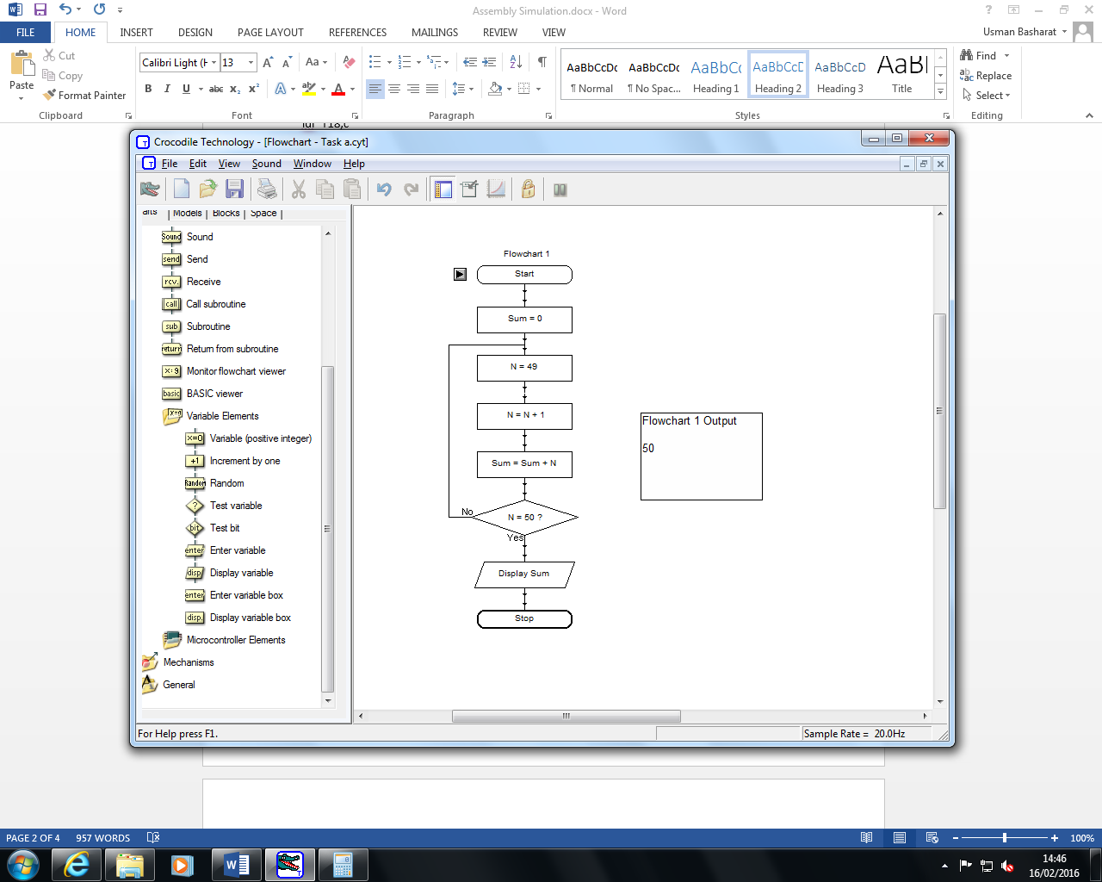

1. Load the Flowol software. Select Help > Tutorial. Read the tutorial
2. Select a mimic of your choice and create something non trivial - this has to be your own design, and not an exercise you have copied from the tutorial. You should incorporate, sequence, branching, loops variables and subroutines in your design.

# Zebra Crossing

